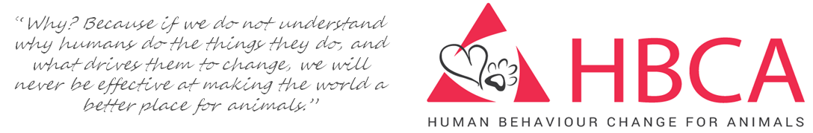

HBCAW Case Study and Story Resource
We would like to develop a resource that provides an overview of interventions and the lessons we can learn from them. Valuable information is not easily accessible to those planning and involved with projects aiming to apply HBC theories and principles. To this end we would be very grateful if you could take a little time to fill in the following sections. I know there is so much to say but in the interest of brevity and accessibility we would like to keep each summary to four sides of A4, ideally shorter. Thank you for your help with this project.
----------------------------------------------------------------------------------------------------------------------------------
Organisation submitting summary:
Contact person (including email address):
Date summary submitted:
Project country:
Keywords and phrases: [please provide terms we can use to categorise the entry for the database. Ideally issue/species/HBC elements – e.g. Theory of Change, understanding motivation, not making assumptions etc]

A story that illustrates what your project does
[This could be an example of a change someone made to help animals, a comment from member of staff about why they are so motivated for the work etc. – anything. We want to hear the ’heart’ of the work.]

Project background:
[This might include a brief background such as how the project started, initial plans and context]

Welfare concerns:
[Very brief summary of key welfare concerns, ideally include how these were assessed, any top-line data and a references if available/pertinent]
D. Overview of intervention:
[Brief summary of activities undertaken focussing on HBC elements]
E. Achievements:
[Brief summary of changes achieved and how this was assessed, ideally with data and focussing on indicators that show HBC (or lack of), use of quotes can bring the project to life too]
F. Challenges:
[Brief overview of key challenges focussing on HBC, including any resulting changes of strategic direction and subsequent achievements or challenges (ie *this* wasn’t working so we did *that* instead)]
G. Sustainability:
[Comments on your perception or evidence-based knowledge of how sustainable the changes were / are likely to be and any update on lasting achievements]
H. Lessons to pass on
[Any words of wisdom to pass on to people considering a similar project with reference to the HBC element/principles applied]
I. Any other info:
[Provide any other info you would like to share. Can also include accompanying info such as a photo – or Ppt file of photos - to illustrate any of above and bring the project to life. Links for further information would also be appreciated and quotes/short stories from animal owners or people involved would be brilliant.]

